|  |  |  |
| --- | --- | --- |
| **شعار جامعة بنها الجديد**f |  |  |
| **Benha University** |  | **Faculty of Computers &**  **Artificial Intelligence** |

**Plantera**

Farm automation system

A senior project submitted in partial fulfillment of the requirements for the degree of Bachelor of Computers and Artificial Intelligence.

**Artificial Intelligence Departement,**

***Project Team***

1. Osama Sayed Ahmed Sharaf
2. Osama Mohamed Hussain
3. Ahmed Mohamed Morsi
4. Amira Ahmed Fathy
5. Dina Abd-Allah Mohamed
6. Mariam Hossam Goda

***Under Supervision of***

**Dr. Mahmoud Abd-elaal**

Benha, February 2022

ABSTRACT

Agriculture automation is the main concern and emerging subject for every country. The world population is increasing at a very fast rate and with an increase in population, the need for food increases briskly. Traditional methods that farmers use are not sufficient enough to serve the increasing demand and so they have to harm the soil by using harmful pesticides in an intensified manner this affects the agricultural practice a lot and, in the end, becomes barren.

Our project talks about using different automation practices such as Artificial Intelligence through Deep Learning and Computer Vision algorithms as well as IOT “Internet of things”.

There are some areas which cause problems in the agriculture field such as crop diseases, lack of irrigation and water management, weed management and pesticide control. Technologies and techniques mentioned before can introduce some solutions for these problems.

Today, there is a rushing need to decode the issues like use of controlled irrigation control and handling effects of the environment over plants in agricultural practice. So, Automation of farming become so important to contribute to facing all the problems mentioned above.

Our project is focusing on some pillars of automating farms, it introduces an automation system that can care for plants without the need for farmers and detect common diseases of plants using different techniques of AI and IoT for watering.

Table of Contents

List of figures iii

1 Chapter 1 Introduction 6

1.1 INTRODUCTION: 6

1.2 Problem Definition: 7

1.3 Objectives: 7

1.4 A Current solution of these problem: 8

1.5 Scope: 8

1.6 Overview about smart agriculture: 8

1.6.1 What is Smart Agriculture? 8

1.6.2 The Need for Automated Agriculture: 9

1.6.3 IoT Applications in Agriculture: 9

1.7 Plantera System Architecture: 10

1.8 The Use of Internet: 11

2 Chapter 2 Analysis & Design 12

2.1 User and System Requirements: 12

2.1.1 User Requirements: 12

2.1.2 System Requirements: 12

2.2 Function and non-function requirements: 13

2.2.1 Function requirements: 13

2.2.2 Non-function Requirements: 14

2.3 System design: 15

2.3.1 Block diagram: 15

2.3.2 Use case: 16

2.3.3 Activity Diagrams: 17

21

2.3.4 ERD Diagram: 23

2.3.5 Class diagram: 24

2.3.6 Gant chart: 25

2.3.7 Database Design: 26

3 Chapter 3 Hardware and Software 27

3.1 Hardware: 27

3.1.1 Hardware design: 27

3.1.2 Components: 27

3.1.3 NodeMCU: 28

3.1.4 XH-M603 Charging Control Module: 28

3.1.5 Solar Panel 18V 10W: 29

3.1.6 Lead acid Battery: 30

3.1.7 DC-DC converter: 30

3.1.8 Soil Moisture Sensor: 31

3.1.9 DHT 11: 31

3.1.10 Rain sensor: 31

3.2 Software: 32

3.2.1 Mobile app (flutter): 32

3.2.2 Website: 41

4 References 43

List of figures

[Figure 1: Smart Agriculture for Sustainable Food Security Using Internet of Things (IoT) 11](https://fcibuedu-my.sharepoint.com/personal/osama192129_fci_bu_edu_eg/Documents/Plantera.docx#_Toc127208015)

[Figure 2: Block Diagram 15](https://fcibuedu-my.sharepoint.com/personal/osama192129_fci_bu_edu_eg/Documents/Plantera.docx#_Toc127208016)

[Figure 3: Use case 16](https://fcibuedu-my.sharepoint.com/personal/osama192129_fci_bu_edu_eg/Documents/Plantera.docx#_Toc127208017)

[Figure 4: Activity Diagram 1 17](https://fcibuedu-my.sharepoint.com/personal/osama192129_fci_bu_edu_eg/Documents/Plantera.docx#_Toc127208018)

[Figure 5: Activity Diagram 2 18](https://fcibuedu-my.sharepoint.com/personal/osama192129_fci_bu_edu_eg/Documents/Plantera.docx#_Toc127208019)

[Figure 6: Activity Diagram 3 19](https://fcibuedu-my.sharepoint.com/personal/osama192129_fci_bu_edu_eg/Documents/Plantera.docx#_Toc127208020)

[Figure 7: Activity Diagram 4 20](https://fcibuedu-my.sharepoint.com/personal/osama192129_fci_bu_edu_eg/Documents/Plantera.docx#_Toc127208021)

[Figure 8: Activity Diagram 5 21](https://fcibuedu-my.sharepoint.com/personal/osama192129_fci_bu_edu_eg/Documents/Plantera.docx#_Toc127208022)

[Figure 9: Activity Diagram 6 21](https://fcibuedu-my.sharepoint.com/personal/osama192129_fci_bu_edu_eg/Documents/Plantera.docx#_Toc127208023)

[Figure 10: Activity Diagram 7 22](https://fcibuedu-my.sharepoint.com/personal/osama192129_fci_bu_edu_eg/Documents/Plantera.docx#_Toc127208024)

[Figure 11: ERD Diagram 23](https://fcibuedu-my.sharepoint.com/personal/osama192129_fci_bu_edu_eg/Documents/Plantera.docx#_Toc127208025)

[Figure 12: Class Diagram 24](https://fcibuedu-my.sharepoint.com/personal/osama192129_fci_bu_edu_eg/Documents/Plantera.docx#_Toc127208026)

[Figure 13 Project Gantt Chart 25](https://fcibuedu-my.sharepoint.com/personal/osama192129_fci_bu_edu_eg/Documents/Plantera.docx#_Toc127208027)

[Figure 14 Hardware design 27](https://fcibuedu-my.sharepoint.com/personal/osama192129_fci_bu_edu_eg/Documents/Plantera.docx#_Toc127208028)

[Figure 15 NodeMCU 28](https://fcibuedu-my.sharepoint.com/personal/osama192129_fci_bu_edu_eg/Documents/Plantera.docx#_Toc127208029)

[Figure 16 XH-M603 28](https://fcibuedu-my.sharepoint.com/personal/osama192129_fci_bu_edu_eg/Documents/Plantera.docx#_Toc127208030)

[Figure 17 Solar Panel 29](https://fcibuedu-my.sharepoint.com/personal/osama192129_fci_bu_edu_eg/Documents/Plantera.docx#_Toc127208031)

[Figure 18 Lead acid Battery 30](https://fcibuedu-my.sharepoint.com/personal/osama192129_fci_bu_edu_eg/Documents/Plantera.docx#_Toc127208032)

[Figure 19 DC-DC converter 30](https://fcibuedu-my.sharepoint.com/personal/osama192129_fci_bu_edu_eg/Documents/Plantera.docx#_Toc127208033)

[Figure 20 Soil moisture sensor 31](https://fcibuedu-my.sharepoint.com/personal/osama192129_fci_bu_edu_eg/Documents/Plantera.docx#_Toc127208034)

[Figure 21 DHT 11 31](https://fcibuedu-my.sharepoint.com/personal/osama192129_fci_bu_edu_eg/Documents/Plantera.docx#_Toc127208035)

[Figure 22 Rain sensor 31](https://fcibuedu-my.sharepoint.com/personal/osama192129_fci_bu_edu_eg/Documents/Plantera.docx#_Toc127208036)

[Figure 23 Login page 32](https://fcibuedu-my.sharepoint.com/personal/osama192129_fci_bu_edu_eg/Documents/Plantera.docx#_Toc127208037)

[Figure 24 Forget pass Page 33](https://fcibuedu-my.sharepoint.com/personal/osama192129_fci_bu_edu_eg/Documents/Plantera.docx#_Toc127208038)

[Figure 25 farm page 34](https://fcibuedu-my.sharepoint.com/personal/osama192129_fci_bu_edu_eg/Documents/Plantera.docx#_Toc127208039)

[Figure 26 Menu page 35](https://fcibuedu-my.sharepoint.com/personal/osama192129_fci_bu_edu_eg/Documents/Plantera.docx#_Toc127208040)

[Figure 27 Account info page 36](https://fcibuedu-my.sharepoint.com/personal/osama192129_fci_bu_edu_eg/Documents/Plantera.docx#_Toc127208041)

[Figure 28 Setting page 37](https://fcibuedu-my.sharepoint.com/personal/osama192129_fci_bu_edu_eg/Documents/Plantera.docx#_Toc127208042)

[Figure 29 Detect disease page 38](https://fcibuedu-my.sharepoint.com/personal/osama192129_fci_bu_edu_eg/Documents/Plantera.docx#_Toc127208043)

[Figure 30 Farms page 39](https://fcibuedu-my.sharepoint.com/personal/osama192129_fci_bu_edu_eg/Documents/Plantera.docx#_Toc127208044)

[Figure 31 Farm info page 40](https://fcibuedu-my.sharepoint.com/personal/osama192129_fci_bu_edu_eg/Documents/Plantera.docx#_Toc127208045)

[Figure 32 Home page 41](https://fcibuedu-my.sharepoint.com/personal/osama192129_fci_bu_edu_eg/Documents/Plantera.docx#_Toc127208046)

[Figure 33 Pricing Page 41](https://fcibuedu-my.sharepoint.com/personal/osama192129_fci_bu_edu_eg/Documents/Plantera.docx#_Toc127208047)

[Figure 34 Request page 42](https://fcibuedu-my.sharepoint.com/personal/osama192129_fci_bu_edu_eg/Documents/Plantera.docx#_Toc127208048)

# Chapter 1 Introduction

## INTRODUCTION:

In recent years, there has been a rapid improvement in technologies with advances in the development of artificial intelligence and the Internet of Things. We've been pushing our boundaries in the thought process and trying to fuse the natural brain with an artificial machine, and this exploration that's happening has given birth to a whole new field called artificial intelligence. Artificial intelligence falls within the field of computer science and helps to increase the success rate of tasks that require tremendous effort and energy.

Artificial intelligence AI has been applied in various fields, it has been used in education, finance, agriculture, security, medical sciences, and other sectors. Its implementation relies on training or machine learning to extract patterns from feeding data.

With the Internet of Things IoT: the idea of connecting real-world objects to each other, will fundamentally change the way users organize, obtain, and consume information. The Internet of Things enables various applications (monitoring and selecting crop growth, irrigation decision support, etc.) in the field of digital agriculture. We will use AI approaches in agricultural field in our project.

In our project, we will combine artificial intelligence and the Internet of Things and use them in the agricultural field.

## Problem Definition:

The main problem that farmers face is the correct (accurate) care of the plants, where the care is done by a lot of manpower and a lot of resources (such as water and fertilizer), and sometimes despite providing the resources that the plants need, the fruits or the resulting crop are not the best, for example: In normal agricultural fields, farmers waste a lot of water while irrigating their plants, and they may not know when the appropriate times are to irrigate some types of plants. Also, plants or soil may need fertilizer or chemicals without the farmer’s knowledge, and this may affect plant health, or the amount of crop produced.

While researching providing complete care for plants, we found some problems that farms may face, such as plant disease. It is terrible to notice diseases that harm your plants and discover that when it is too late to treat plants. This may affect the agricultural economy and cause many losses.

## Objectives:

Our main goal is to build an integrated automated agricultural system that helps make farms smart and helps farmers provide the best care for plants. By integrating artificial intelligence with the Internet of Things with the use of web technology, and developing applications using flat AI methods such as deep learning and computer vision with the IoT "Internet of Things" to build an automation system that can provide accurate plant care by automatically watering plants at the right time (when the plant need), discover plant diseases and suggest how to take care of these plants and link these activities in the website and mobile application

## A Current solution of these problem:

The current solution to agricultural problems is that each solution tries to solve each problem independently. For example, there is a system that can irrigate plants intelligently only, and another system that searches for plant diseases. Our goal is to solve more than one problem and integrate it into a broader system that can intelligently irrigate, intelligently detect plant diseases, and predict crop yields publish these algorithms on a website and a simple mobile application so that it is easier for the farmer to control the system via a smartphone.

## Scope:

Our project targets the farmer's owners and agricultural engineers that need to automate their farmers and enhance the quality of production in the farms.

The system is a set of sensors interconnected and controlled by a microcontroller that can be installed on the farm. The system is controlled by applying flutter installed on the farmer's phone. The application is linked to a website to control farmers' accounts and use artificial intelligence methods that have been deployed to help In achieving the goal of automation.

## Overview about smart agriculture:

### What is Smart Agriculture?

In IoT-based smart farming, a system is built for monitoring the crop field with the help of sensors (light, humidity, temperature, soil moisture, etc.) and automating the irrigation system. The farmers can monitor the field conditions from anywhere. IoT-based smart farming is highly efficient when compared with the conventional approach.

The applications of IoT-based smart farming not only target conventional, large farming operations, but could also be new levers to uplift other growing or common trends in agricultural like organic farming, family farming (complex or small spaces, particular cattle and/or cultures, preservation of particular or high-quality varieties etc.), and enhance highly transparent farming. [1]

### The Need for Automated Agriculture:

Smart Agriculture helps farmers to avoid water wastage and improve the quality of crop growth in their fields by:

* irrigating at the correct times.
* minimizing runoffs and other wastages.
* determining the soil moisture levels accurately.

Replacing manual irrigation with automatic valves and systems also does away with the human error element (e.g., forgetting to turn off a valve after watering the field) and is instrumental in saving energy, time, and valuable resources.[2]

### IoT Applications in Agriculture:

* Smart Irrigation.

Smart water management solution is high in demand and most popular IoT Application in Agriculture. Poor irrigation system and dependency on monsoon have made this application popular among farmers to boost their crop yield and ensure minimum water wastage.

* Precision Farming Applications.

Precision agriculture (PA) or satellite farming or site-specific crop management (SSCM) is a farming management concept used to observe, measure, and respond to inter and intra-field variability in crops. UAVs (Unmanned Aerial Vehicle) or Drone is the first application used in PA.

* Crop Management.

One more type of IoT Application in agriculture and another element of precision farming is crop management devices. Just like weather stations, they should be placed in the field to collect data specific to crop farming; from temperature and precipitation to leaf water potential and overall crop health, these can all be used to readily collect data and information for improved farming practices.

* Smart Greenhouse Applications.

Greenhouse automation and monitoring system is the most popular application in smart greenhouse applications. There are a few applications which are under testing and being used in a live environment. [3]

## Plantera System Architecture:

A smart microcontroller (which serves as the ‘information gateway’) lies at the heart of the automated agriculture infrastructure.

Soil moisture sensors and temperature sensors, which are placed on the fields, send real-time data to the microcontroller.

Generally, a ‘moisture/temperature range’ is specified, and whenever the actual values are out of this range, the microcontroller automatically switches on the water pump, which is mounted on it with output pins.

The entire system can be managed by the end-user through a dedicated mobile application with the addition of some useful features for the farmer:

* Photographing plants, detecting diseases, and suggesting treatment using artificial intelligence.
* Predict the amount of crop using artificial intelligence based on soil properties and quality.

Smart Agriculture enables farmers to remotely monitor and irrigate their fields and provide the best care to plants, without any hassle. [4]

## The Use of Internet:

The flow of information to and from the centralized gateway (here, the microcontroller) must be supported by stable internet services.

Wireless low-power networks (e.g., Lora WAN, Sigfox, Zigbee, …etc.) can easily be used to power the sensors. These sensors send field information to the local computer of the user or to a cloud network (as required). [3]

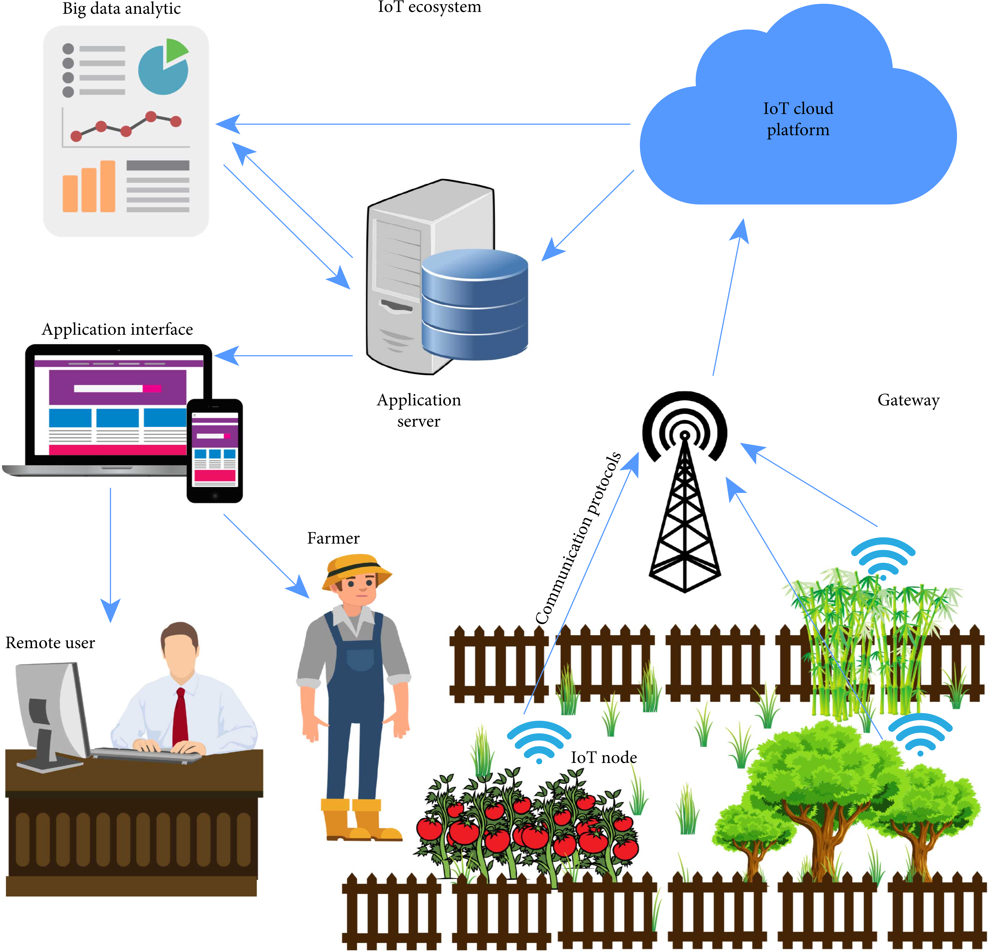

Figure 1: Smart Agriculture for Sustainable Food Security Using Internet of Things (IoT)

# Chapter 2 Analysis & Design

## User and System Requirements:

### User Requirements:

we focus on farm plants, for example: (apples, tomatoes, corn, and potatoes) for Helping people with low experience and who have no background in how to care for plants.

The proposed system is a smartphone application used for disease detection and guidance People (especially people who are not specialized in the cultivation process) It is mainly determined from the photo taken of the plant Through the phone's camera, which is suspected of being infected, and checking the form if it has a specific disease or not.

he Plantera system must transmit daily data on some soil and air properties.

An annual report should be sent on the expected crop quantity.

### System Requirements:

1- User will see the facilities hardware and the system application then User sees the plan prices.

2- if the user wants the device Press the contact us button and we will contact you through Email.

3- The hardware company has given the user login info to enter his profile then the User enters the login farm ID and password if the Correct login and password User successfully logs in.

4- User will go to the farm profile and be able to User takes/upload a picture and send it to the Disease detection Model and we get disease detection feedback.

5- The hardware is connected to the software to receive the information from the sensors Read the soil moisture sensor ... Read the humidity sensor ... Read the temperature sensor ... Read the rain sensor ... and send the information to NodeMCU These data will be sent to the software. If the read data matches the criteria of irrigation of the plan.

6- User logs in to the system and then Click the crop yield button to know it for this season ... Plant data that is transformed by the hardware will go to the Model to predict the crop yield.

## Function and non-function requirements:

### Function requirements:

The system allows the administrator to add or delete accounts through the website.

The system allows the administrator to modify data and accounts through the website.

The system allows the user to control the degree of moisture in the soil through the application.

The system allows the user to choose the plant to be cared for.

Sensors and devices must be installed on the farm.

The system must be connected to the internet to keep track of the plants (internet availability at the farm).

The farmer must log in with his account.

### Non-function Requirements:

The system must be compatible with all farms (large and small).

The system must be running on Android and iOS.

the system should be reliable.

The system works without the Internet, but connect the Internet for follow-up only.

The system does not need an electricity source because it is powered by solar energy.

## System design:

### Diagram Description automatically generatedBlock diagram:

Figure 2: Block Diagram

### Use case:

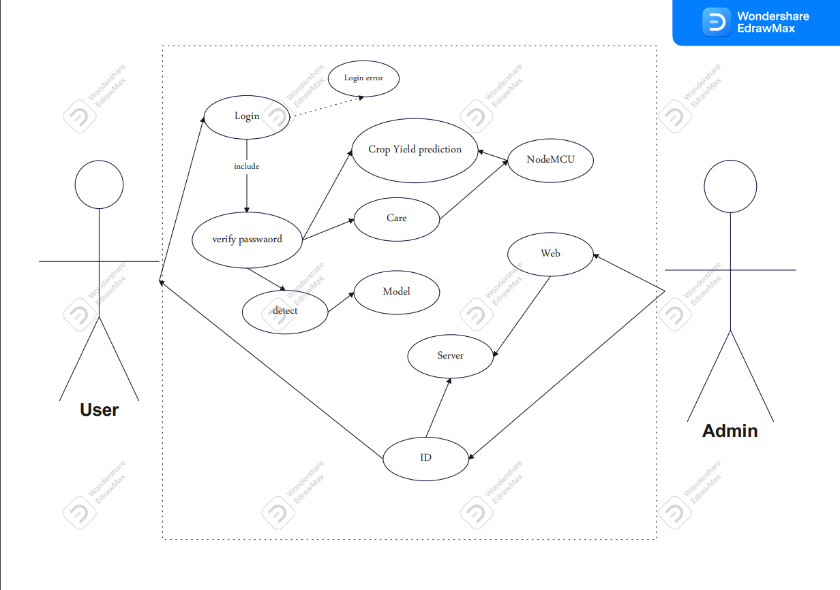

Figure 3: Use case

### Activity Diagrams:

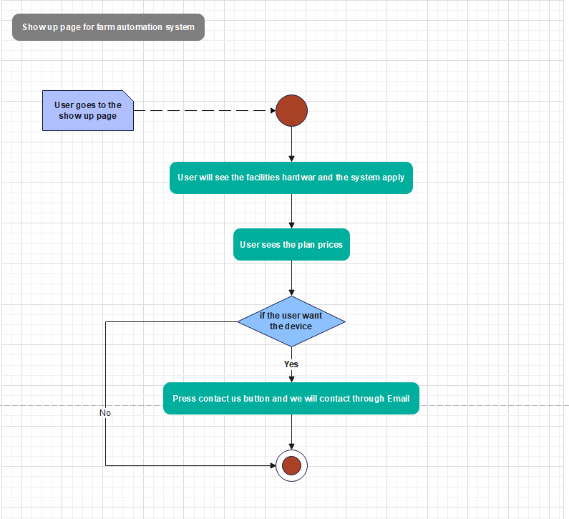

Figure 4: Activity Diagram 1

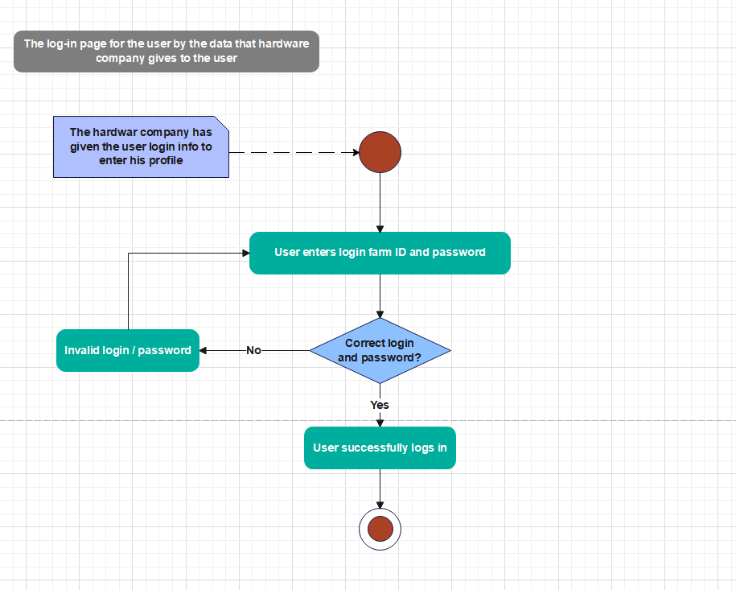

Figure 5: Activity Diagram 2

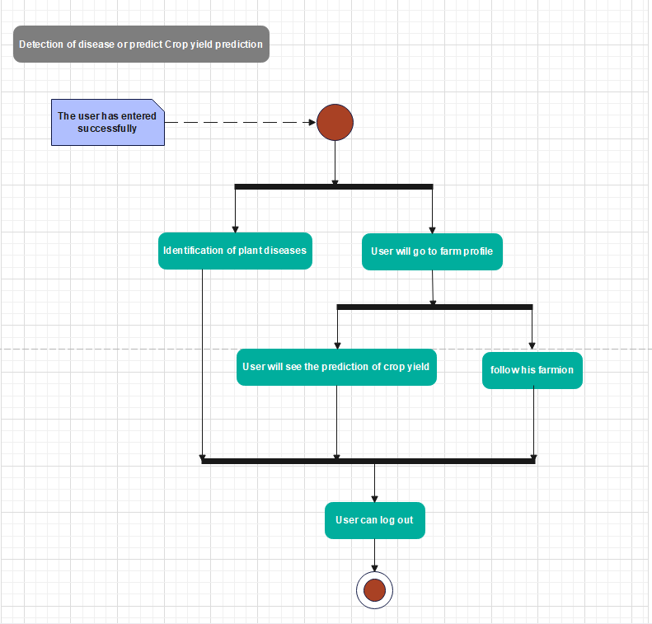

Figure 6: Activity Diagram 3

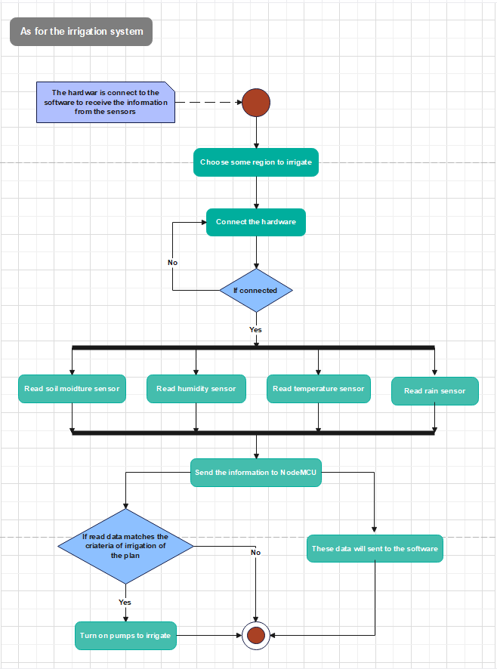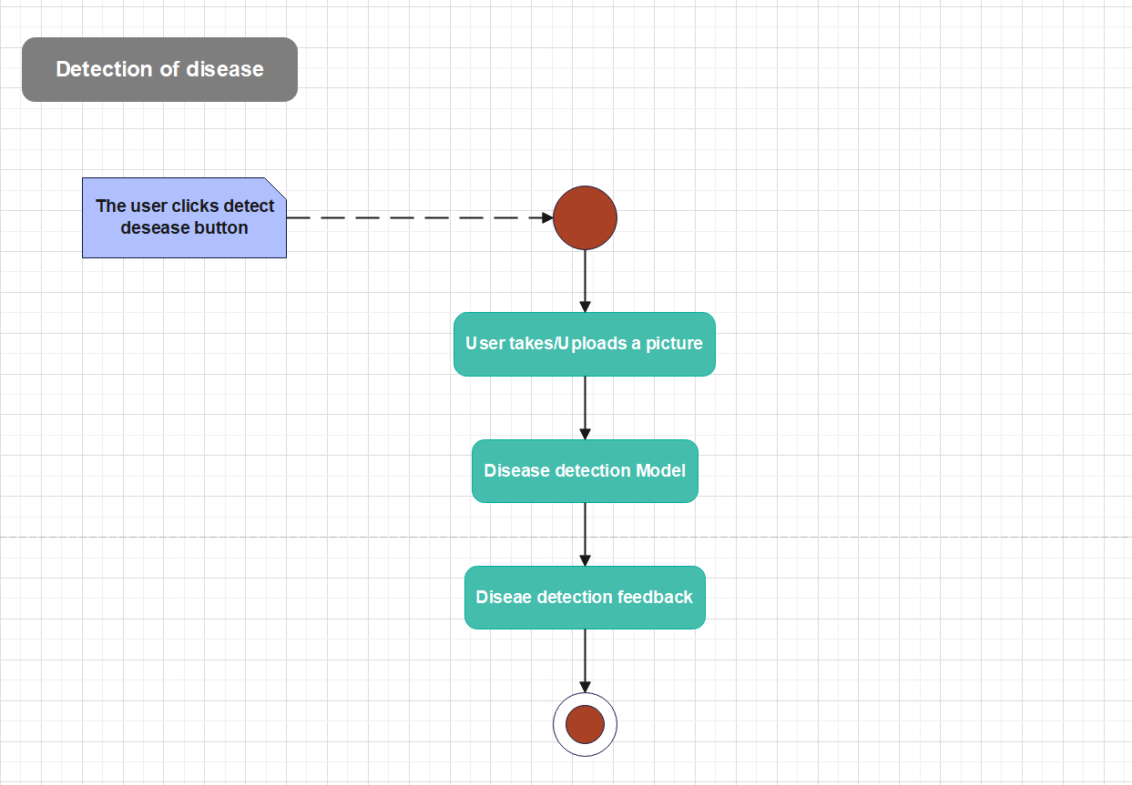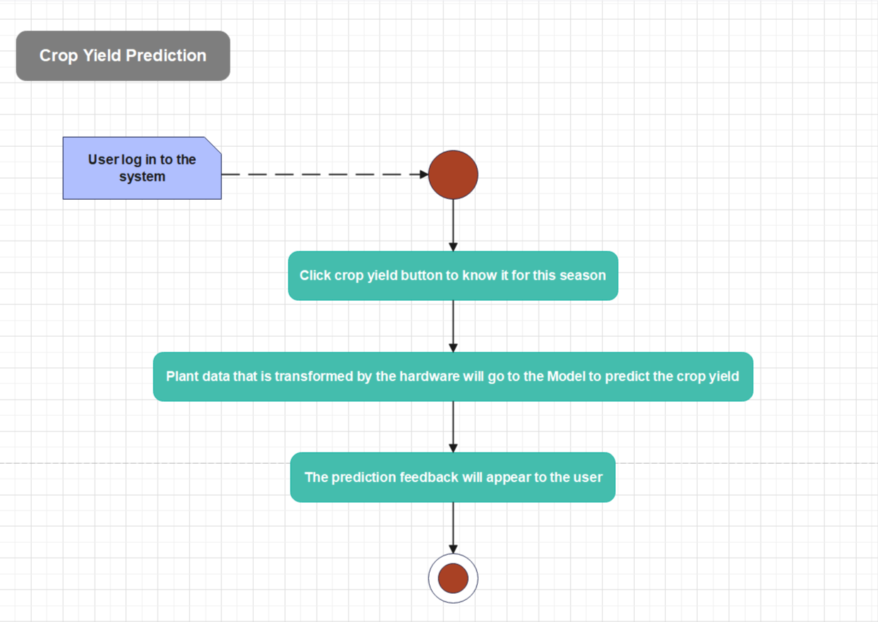

Figure 7: Activity Diagram 4

Figure 8: Activity Diagram 5

Figure 9: Activity Diagram 6

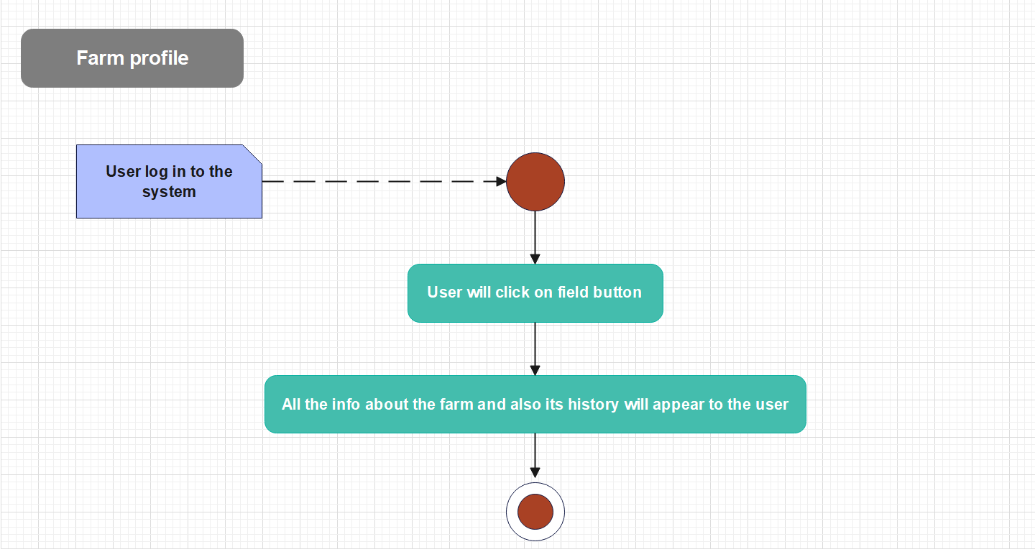

Figure 10: Activity Diagram 7

### ERD Diagram:

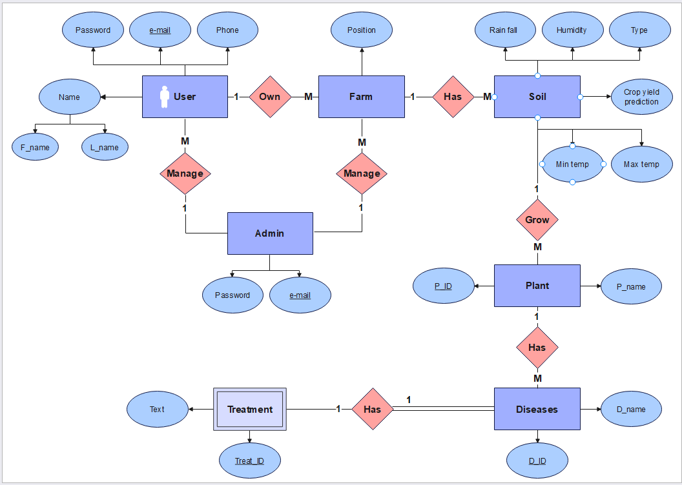

Figure 11: ERD Diagram

### Diagram, schematic Description automatically generatedClass diagram:

Figure 12: Class Diagram

### Chart Description automatically generatedGant chart:

Figure 13 Project Gantt Chart

### Database Design:

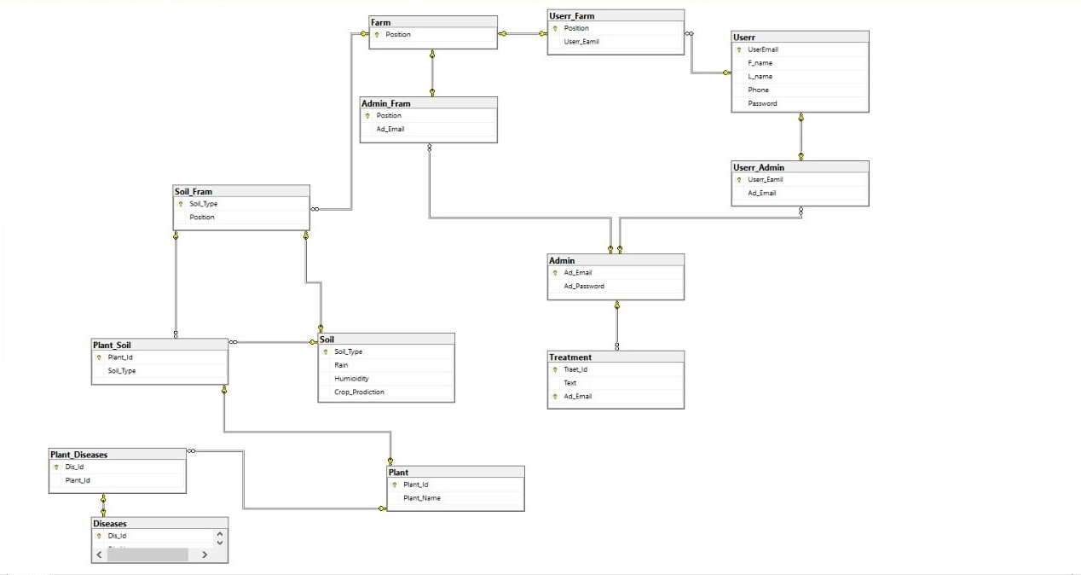

# Chapter 3 Hardware and Software

## Hardware:

### Diagram Description automatically generatedHardware design:

Figure 14 Hardware design

### Components:

1. NodeMCU (ESP8266 WiFi Programming & Development Kit) CP2102
2. XH-M603 Charging Control Module
3. Solar Panel 12V 10W
4. Lead acid Battery, 12V 5AH
5. DC-DC Step Down converter
6. Soil Moisture Sensor
7. DHT11 Temperature & Humidity Sensor
8. Rain sensor

### NodeMCU:

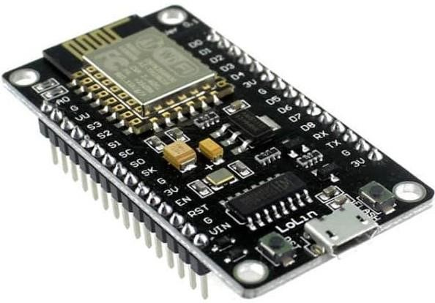NodeMCU is an open-source firmware and development board that helps in prototyping IoT product with Lua programming language or Arduino IDE. It has on board wi-fi available through which IoT applications becomes easy to build.

Figure 15 NodeMCU

The development board is based on the ESP8266 Wi-Fi chip with 10 GPIO and 1 ADC input.

Multiple GPIO pins on the board allow connecting the board with other peripherals and can generate PWM, I2C, SPI, and UART serial communications. [5]

### A picture containing electronics, circuit Description automatically generatedXH-M603 Charging Control Module:

The XH-M603 is a PCB control module used to charge lithium batteries, Lead-acid, nickel-cadmium,nickel-metal hydride, lithium-ion and polymer.

You can assemble your own Lithium battery charger by using this charger module. The module can also be used for solar panels. [6]

Figure 16 XH-M603

### Solar Panel 18V 10W:

Solar panels also known as PV panels are used to convert light from the sun, which is composed of particles of energy called photons, into electricity that can be used to power electrical loads.

A solar panel is a collection of solar (or photovoltaic) cells, which can be used to generate electricity through photovoltaic effect. These cells are arranged in a grid-like pattern on the surface of solar panels. Thus, it may also be described as a set of photovoltaic modules, mounted on a structure supporting it. [7]

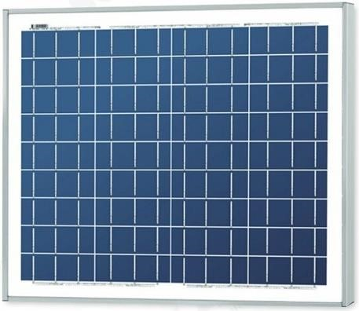

Figure 17 Solar Panel

The type of PV panel used in this work is Polycrystalline as shown in Fig.16 and its specifications are presented in Table.

|  |  |
| --- | --- |
| **Electrical Characteristics** | **Value** |
| Maximum Power(Pmax) | 20W |
| Maximum Power Voltage(Vmp) | 18V |
| Maximum Power Current(Imp) | 1.11A |
| Open Circuit Voltage(Voc) | 22.1V |
| Short Circuit Current(Isc) | 1.16A |
| Maximum Series Fuse | 15A |
| Power Selection | 13% |
| Dimensions | 355×360mm |
| Maximum System Voltage | IEC1000V |

The reason behind choosing this panel is to design a small prototype that can be flexible and easy to use.

### A sign on a wall Description automatically generated with low confidenceLead acid Battery:

Figure 18 Lead acid Battery

The battery which uses sponge lead and lead peroxide for the conversion of the chemical energy into electrical power, such type of battery is called a lead acid battery. The lead acid battery is most used in the power stations and substations because it has higher cell voltage and lower cost. [8]

VRLa Lead acid Battery, 12V 5AH.

UL Series VRLA batteries can be used for All Purpose, Emergency Lighting, Backup Power Supplies, Aircraft Signals and Security Systems.

### A picture containing electronics Description automatically generatedDC-DC converter:

The Buck converter is a form of a DC-DC converter which steps down the level of supply voltage and provides it at the output.

DC-DC Step Down Converter HVS Variable 3A High Input Voltage (4.5~60Vdc to 3~35Vdc).

Figure 19 DC-DC converter

The DC-DC module based on LM2596HVS advocate current to 3.0A, but only to 1.8A. However, being introduced module adds a heatsink, using high-power devices. This module can easily reach 2A, add heat sink circumstances can reach 3A. [9]

We use DC-DC Buck converter to step down supply voltage "PV panel" from 12 volt to 6 volt, and this way is the optimal method to get variable voltage with high efficiency and lowering the power losses.

### Soil Moisture Sensor:

The moisture sensor can be used to detect the moisture of the soil.

Output voltage increases with the increase of soil moisture.

Figure 20 Soil moisture sensor

### A picture containing electronics Description automatically generatedDHT 11:

The **DHT11**is a commonly used **Temperature and humidity sensor that** comes with a dedicated NTC to measure temperature and an 8-bit microcontroller to output the values of temperature and humidity as serial data. [10]

Figure 21 DHT 11

### A close-up of a circuit board Description automatically generated with medium confidenceRain sensor:

Figure 22 Rain sensor

A rain sensor is one kind of switching device which is used to detect the rainfall. It works like [a switch](https://www.elprocus.com/sound-activated-switch/) and the working principle of this sensor is, whenever there is rain, the switch will be normally closed. [11]

## Software:

The farm system is controlled by two software (mobile app & website).

### Mobile app (flutter):

* 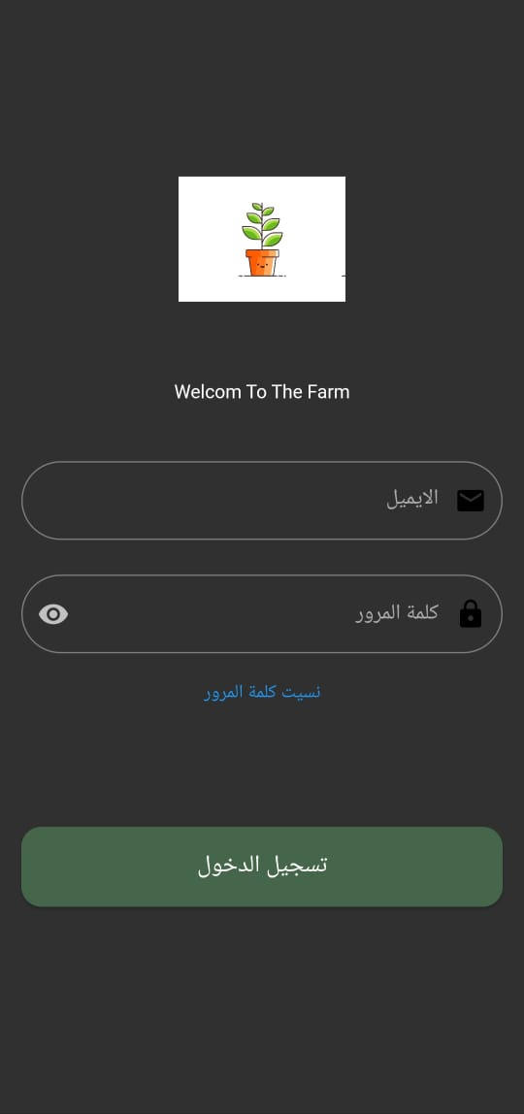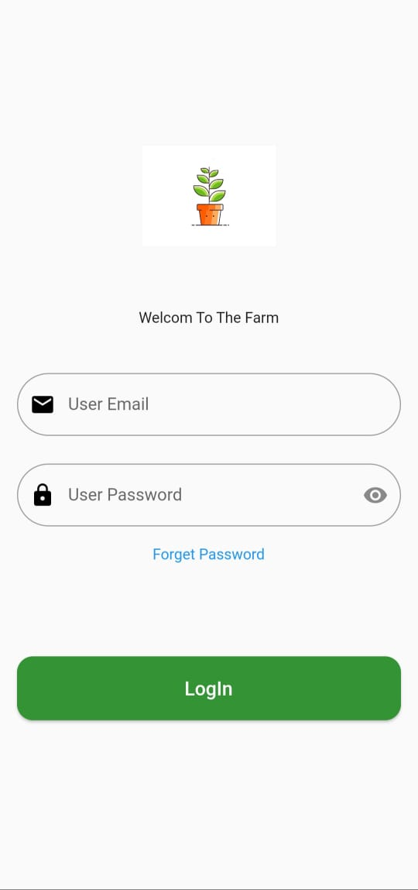In the beginning, this is the login page, where coordination is made with the administrators (the company) to create an e-mail and access it. If the e-mail is correct, the program will be entered; if it is wrong, a message will be sent to try another e-mail. If you forget the password, the Forgot Password button is pressed.

Figure 23 Login page

* This page is to reset the password, where the e-mail registered with the company is entered and press the reset password button, then a message will be sent to the private e-mail to change the password.

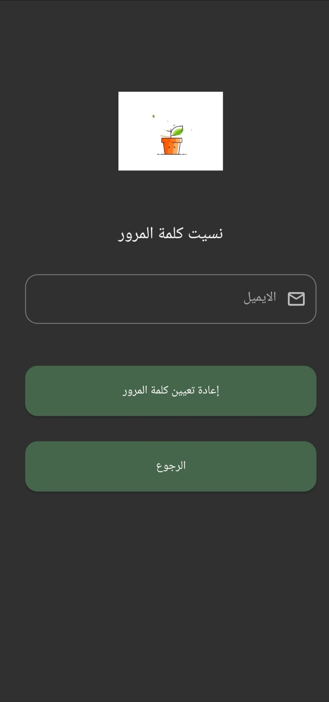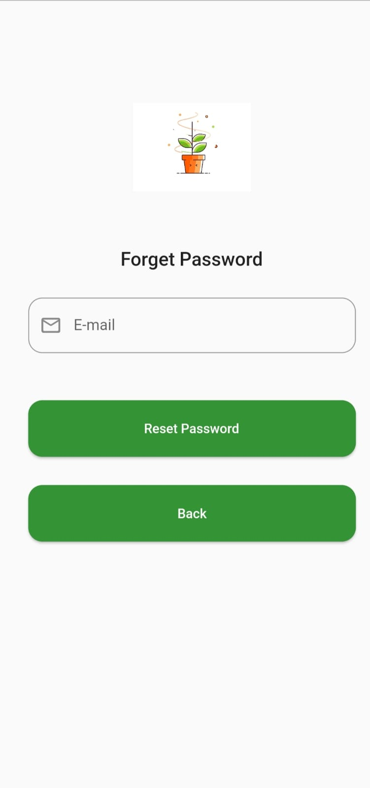

Figure 24 Forget pass Page

* This is the first page in the program to enter the farm or enter to discover if the plant is sick or not.

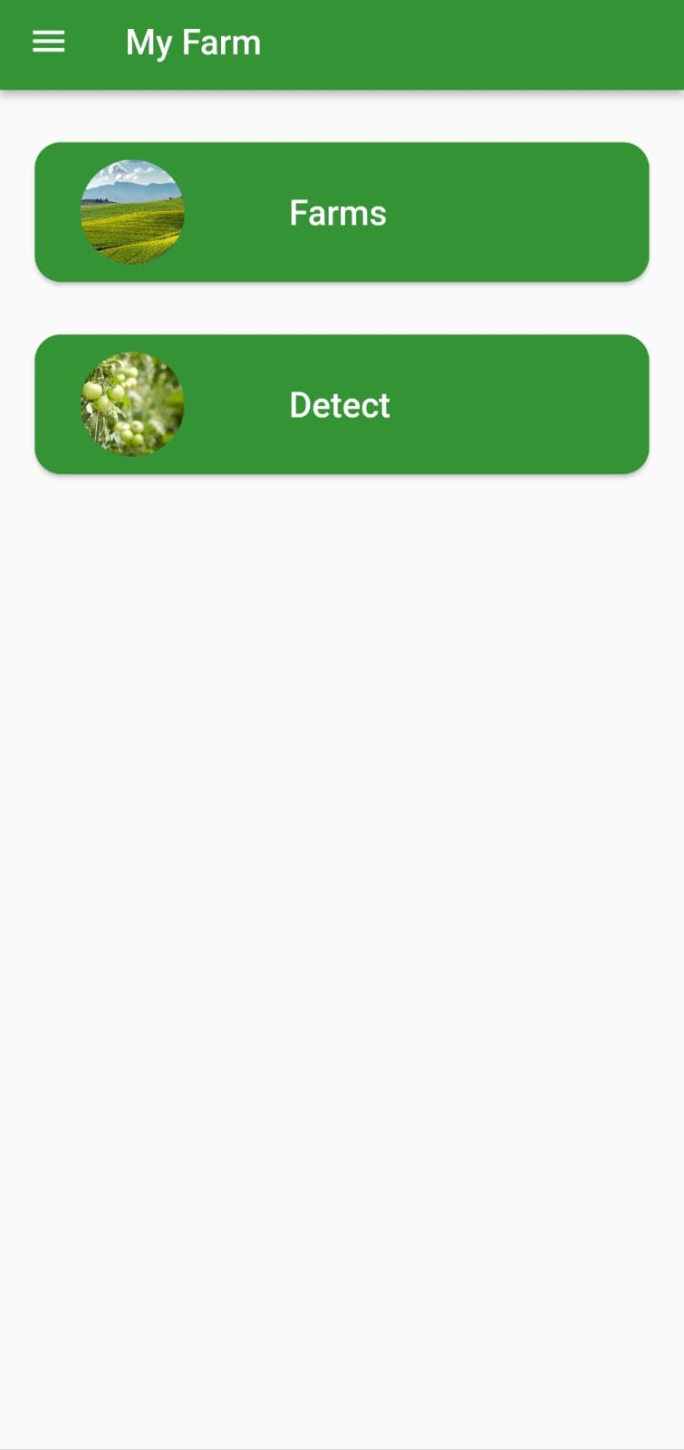

Figure 25 farm page

* This menu is for entering your email, changing settings, logging out, or for help knowing anything about the program.



Figure 26 Menu page

* This is a page for user data, but it is not modified except by the admin.

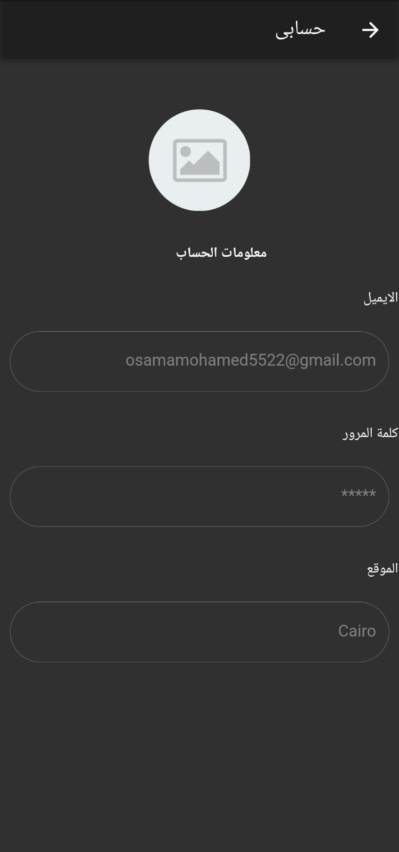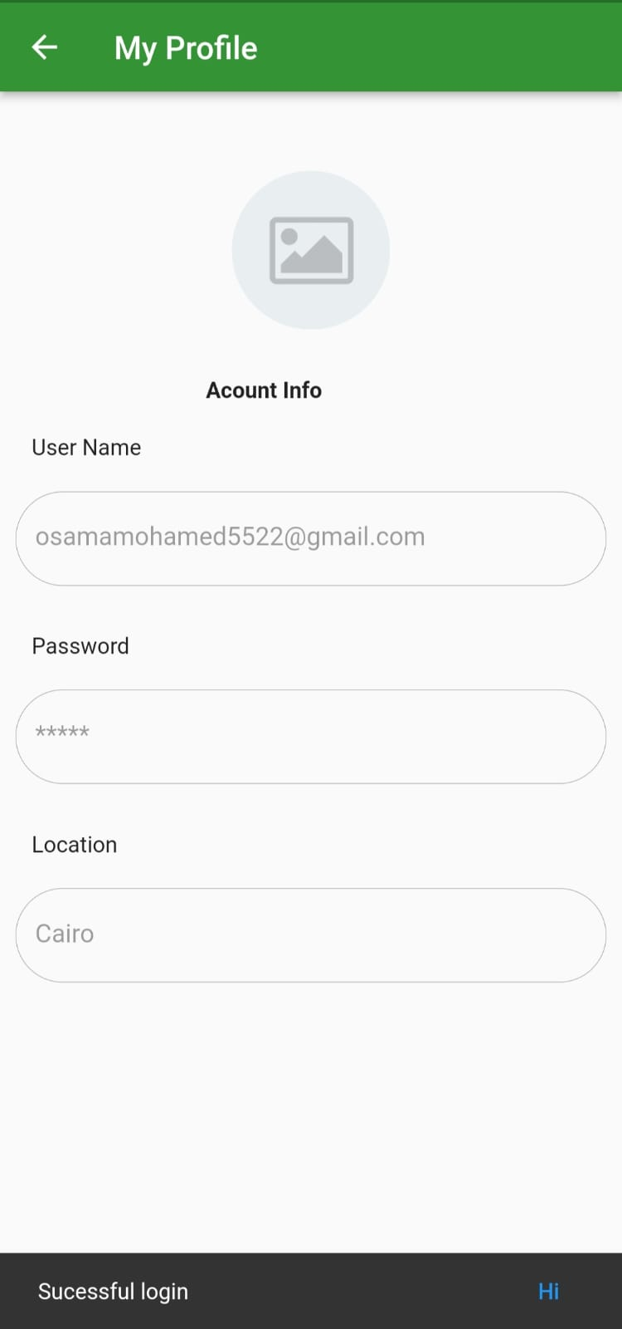

Figure 27 Account info page

* This is a page to change the language (Arabic - English) or change the mode (dark mode - light mode).

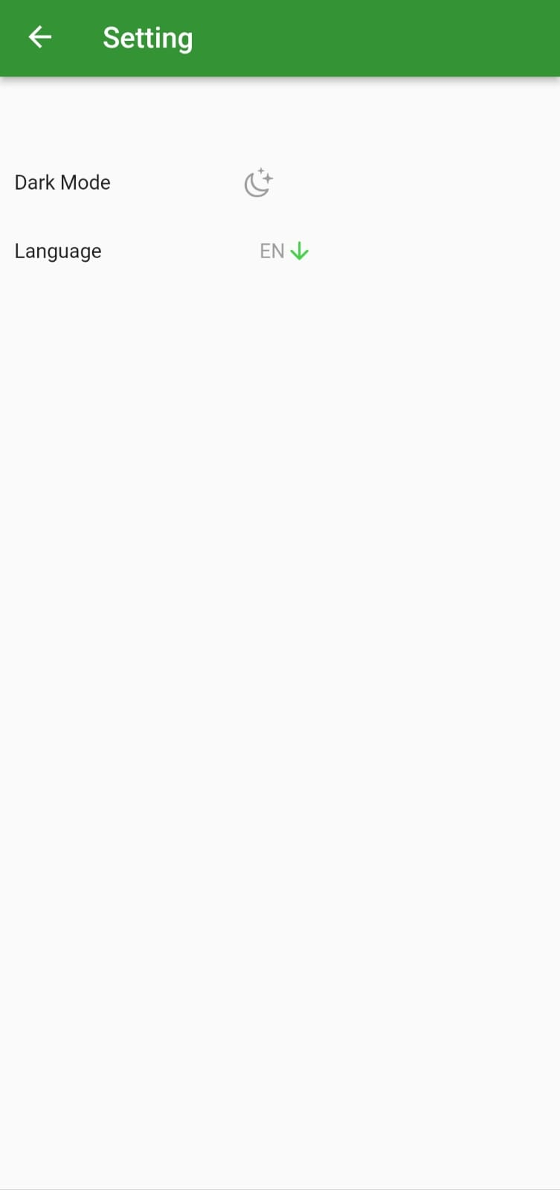

Figure 28 Setting page

* This page is to find out about the plant disease. Either take a picture or choose from the photo gallery, then press the disease detection button to display the disease and the proposed treatment.

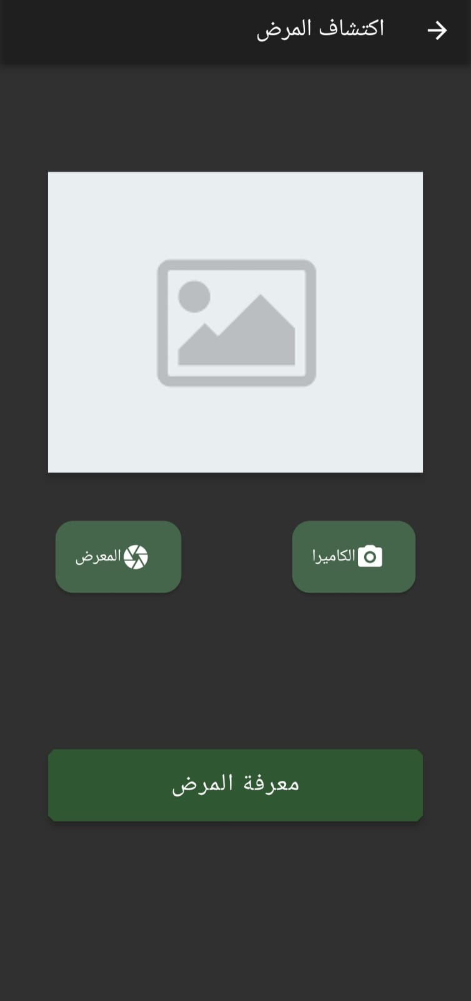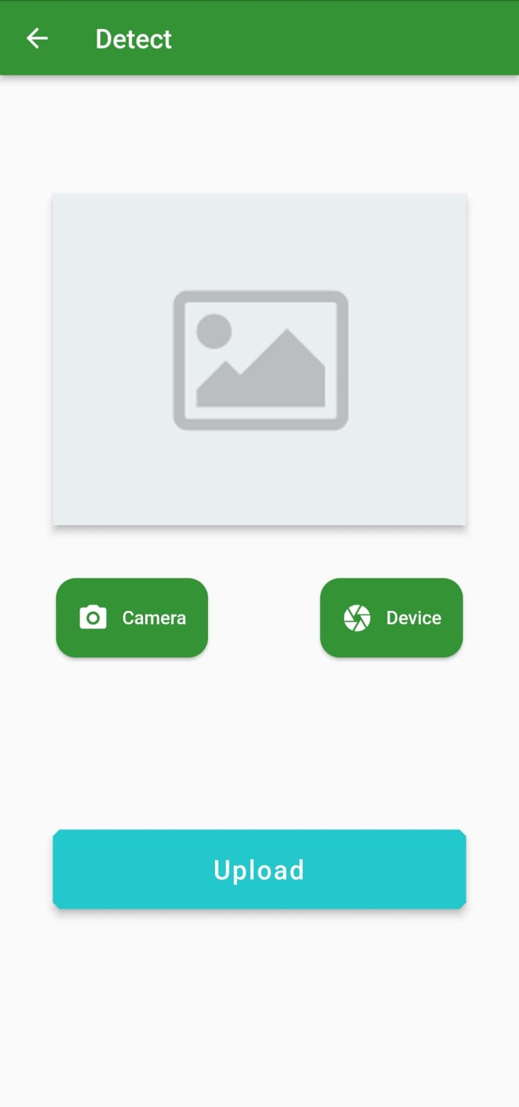

Figure 29 Detect disease page

* This page contains all the user's farms.

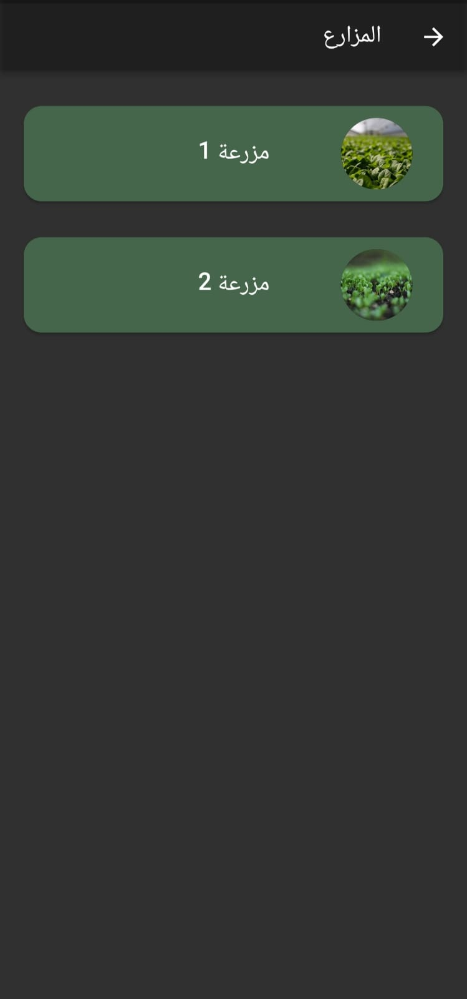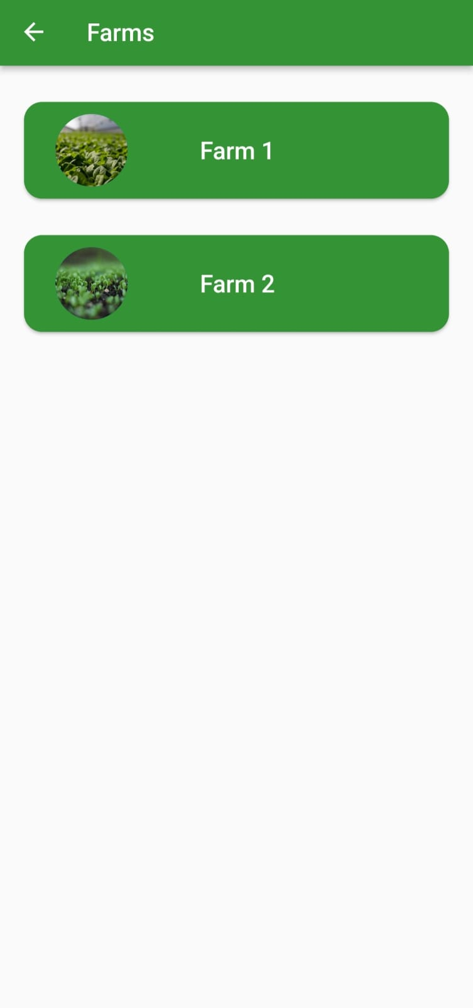

Figure 30 Farms page

* This page contains farm data from air temperature and humidity and ground moisture.
* The plant is selected and based on the type of plant, the appropriate temperature and humidity for growth appear.
* These indicators are the actual temperature and humidity of the farm, and there is a button to predict how much crop will grow on this farm.

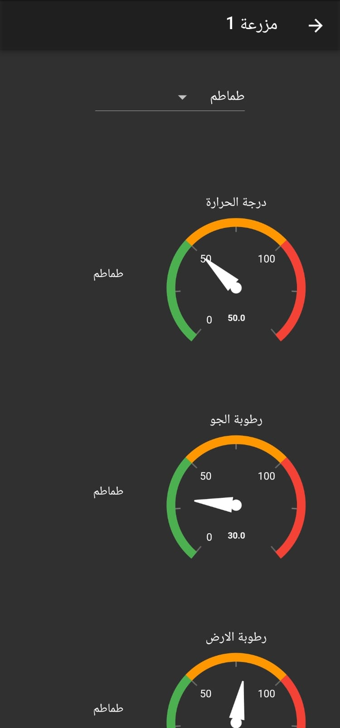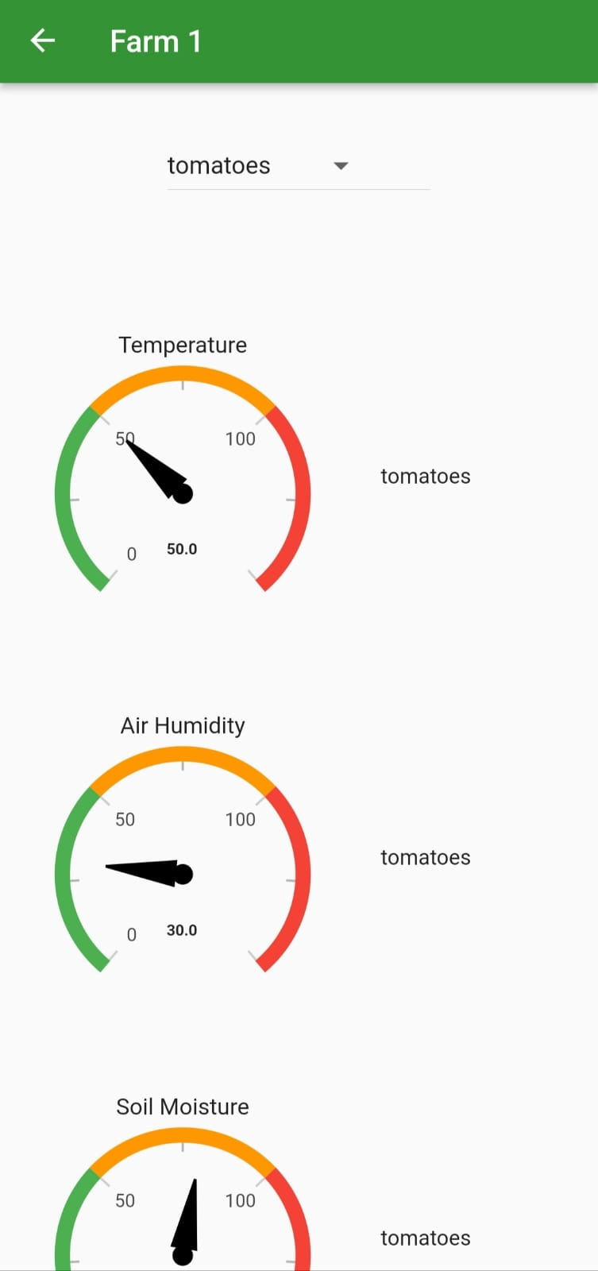

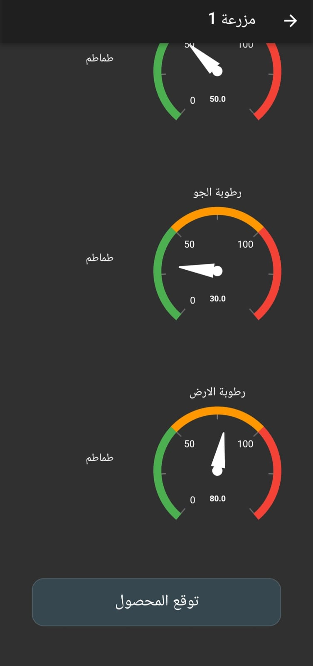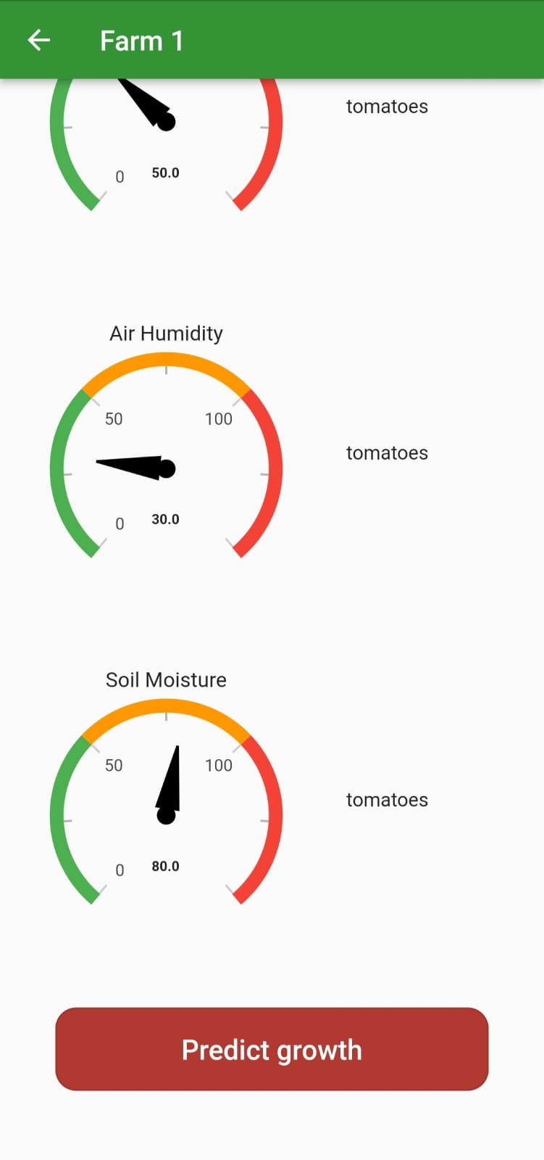

Figure 31 Farm info page

### Website:

* 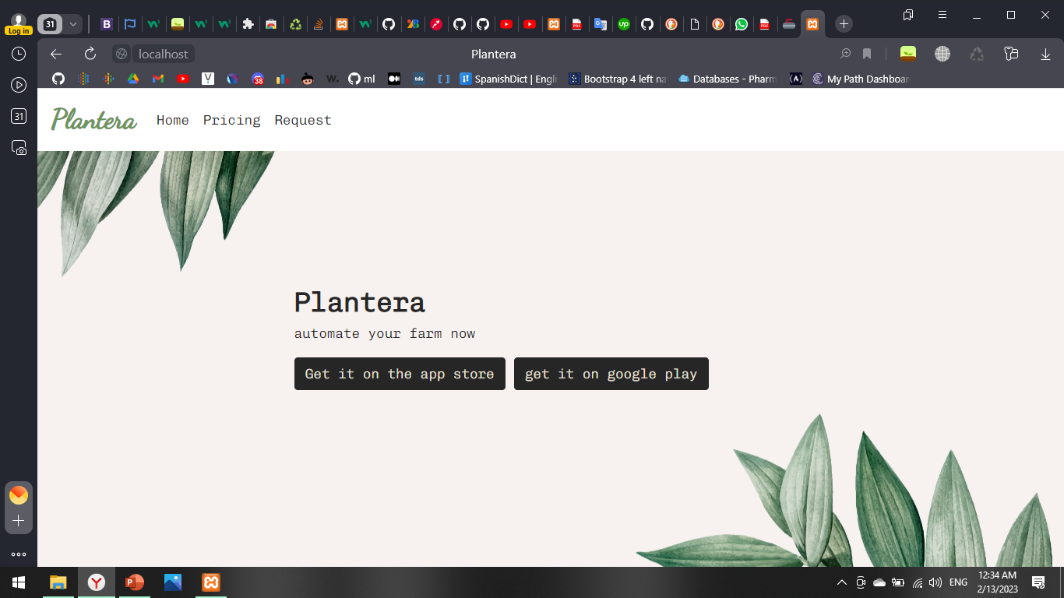The home page, where the user can install the application on both the apple store and google play.

Figure 32 Home page

* 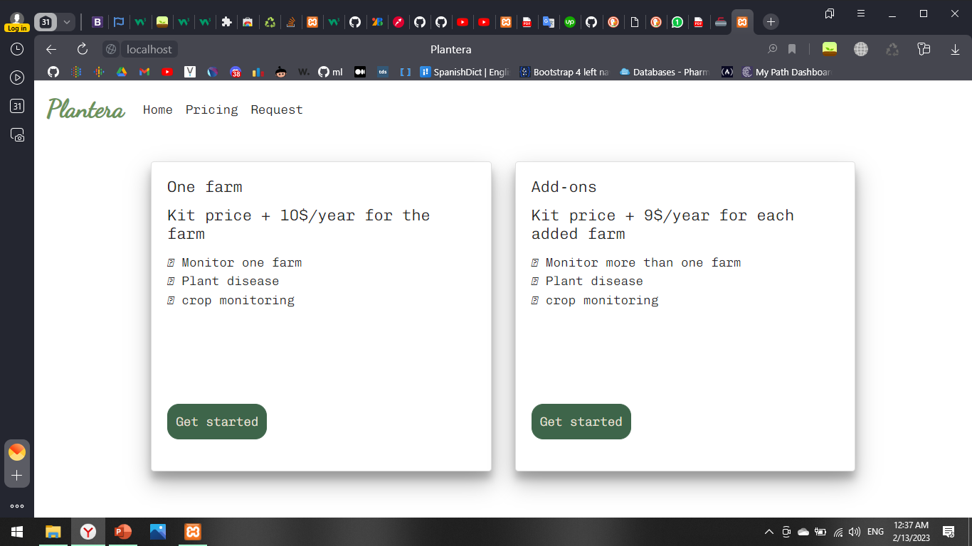Pricing page, where all the plans are available is giving to the user.

Figure 33 Pricing Page

* Request page where the user can request to have the system installed.

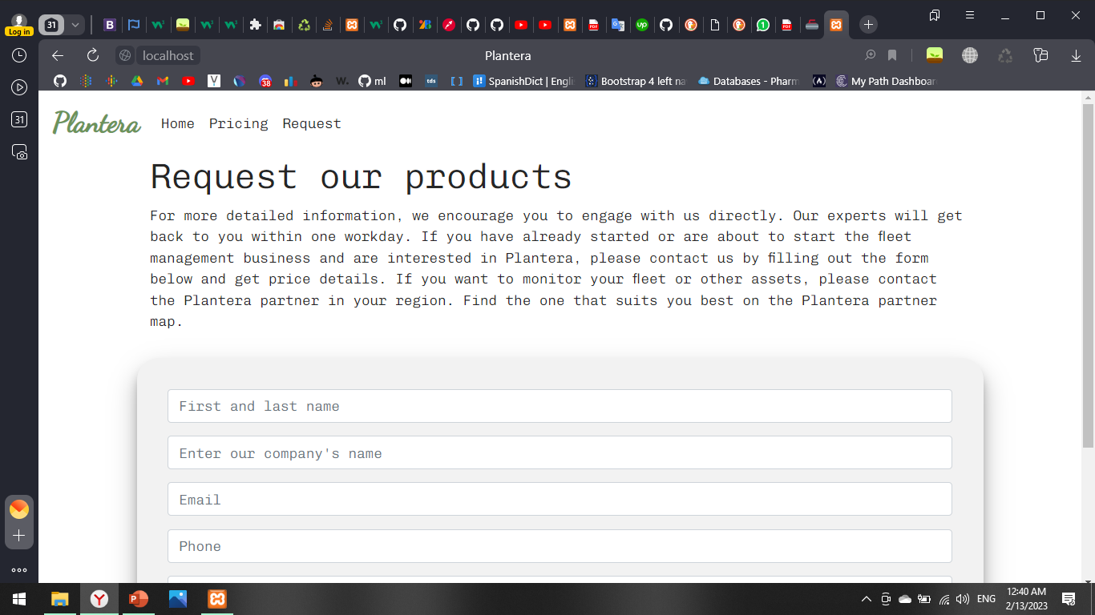

Figure 34 Request page

# References

1. [IoT Applications in Agriculture (iotforall.com)](https://www.iotforall.com/iot-applications-in-agriculture)
2. [Internet of Things (IoT) Applications in Agriculture - Electronicsmedia](https://www.electronicsmedia.info/2017/04/26/internet-things-iot-applications-agriculture/)
3. [Smart Irrigation in IoT: 12 Important Things To Know - DZone IoT](https://dzone.com/articles/smart-irrigation-with-iot-top-12-things-to-know)
4. [Solar Powered Automatic Irrigation System - ECE Projects (elprocus.com)](https://www.elprocus.com/solar-powered-automatic-irrigation-system/)
5. <https://www.circuito.io/blog/iot-projects/>
6. <https://www.katranji.com/tocimages/files/438406-214911.pdf>
7. <https://economictimes.indiatimes.com/definition/solar-panel>
8. [What is Lead Acid Battery? Construction, Working, Discharging & Recharging - Circuit Globe](https://circuitglobe.com/lead-acid-battery.html)
9. [DC-DC Step Down Converter HVS Variable 3A High Input Voltage](https://ram-e-shop.com/product/dc-dc-step-down-converter-variable-3a-high-input-voltage-4-560vdc-to-335vdc/)

[(4.5~60Vdc to 3~35Vdc) - RAM Electronics (ram-e-shop.com)](https://ram-e-shop.com/product/dc-dc-step-down-converter-variable-3a-high-input-voltage-4-560vdc-to-335vdc/)

1. <https://components101.com/sensors/dht11-temperature-sensor>
2. <https://www.elprocus.com/rain-sensor-working-and-its-applications/>